
PROJECT: CUSTOMER CHURN PREDICTION
Student Name |  | Role
Poorni Dasanayake |  | Project Manager
Milan |  | Data Analyst – Predictive Modelling
Virajkumar Shihora |  | Data Analyst – Clustering Analysis
Tanjila |  | Business Analyst
Nishil |  | Data Engineer – Preprocessing & Feature Engineering
Stage 2 Deliverable Training & Testing Split Documentation

Training & Testing Split Documentation

Introduction
One of the simplest processes in the machine learning industry is referred to as a training and testing split that ensures that the model is applied to unknown data. The data used in this project was divided into two subsets: one was training, and the other was testing to test the generalisation capacity of the model. This approach prevents overfitting and provides a reasonable prediction of the way the model will perform on new data.

Split Methodology
The data set was divided to training set and a testing set in the 80: 20 ratio. It means that they used 80 per cent of the data to train the model, and the remaining 20 percent was used to test it. This is a commonly used ratio in machine learning because this ratio provides a balanced trade-off between training effectiveness and evaluation reliability.
The division was also grounded on a stratified sampling approach to ensure that the distribution of the target variable (churn) is the same in both the training and test samples. In this respect, the classification problem area, where the class imbalance may be experienced, is of great significance as the two subsets should be represented by the full dataset in the correct way.

Project Implementation.
The train-test split was carried out with the help of a standard machine learning library; a constant random state was applied in order to make the results repeatable. The separation of the features and target variable was carried out, and the features were separated to facilitate the arrangement and organisation of the model training process.
The data sets obtained are:
- Training data: This information is utilised in the training of the preprocessing and clustering pipeline.
- Testing dataset: This is to run a test on the robustness and stability of the model.
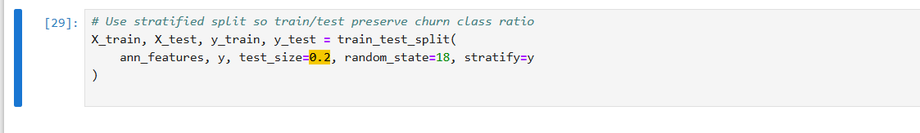
Figure 1: Data splitting

Rationale for the Approach
The idea of an 80:20 split is acceptable since it provides sufficient information to proceed with training without having sufficient information to make an impartial assessment. Stratified sampling will also enhance the proportions of classes, as it is better than the reliability of the split. This gets the model performance a step nearer to the actual performance.

Impact on Model Evaluation
This project has the benefit of splitting the data into training and testing sets, such that the model is subjected to unknown data that provides more credible results. This approach reduces the likelihood of overfitting and increases the validity of the clustering and prediction that is based on an analysis.

